**Task No. 1:** Write a simple stored procedure name “CustomerRecord” that returns the desired Customer record from the Northwind database given a parameter of the CustomerID.

**Solution:**

create procedure CustomerRecord @id nvarchar(10) as begin select * from Customers where CustomerID=@id end

**Output:**

exec CustomerRecord ANATR

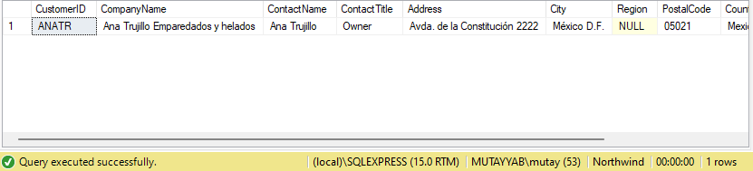

**Task No. 2:** Write a stored procedure name “Territory” that accepts a Territory ID, Territory Description, and Region ID and inserts them as new row in the Territories table in Northwind.

**Solution:**

create procedure Territory @id int ,@desc nvarchar(max),@regionid int as begin

insert into Territories values(@id,@desc,@regionid) ; end

**Output:**

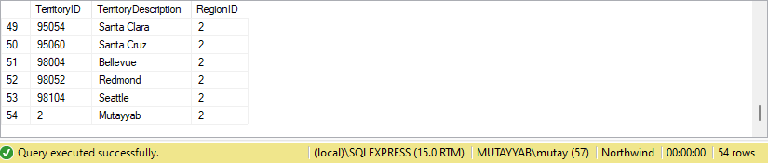exec Territory 2,'Mutayyab',2